IT306 Software Engineering Lab File

MO20, 2K18 batch, VIth Semester, Sec-A

Name – **Ankur Utkarsh**

Roll No – **BTECH/10219/18**



**Department of Computer Science and Engineering**

**Birla Institute of Technology, Mesra, Ranchi - 835215 (India)**

**Case Study No and Title: SIH2020_17; Automated Scientific Storage Facility**

**Brief Description about the case study:**

Central Warehousing Corporation (CWC) is into scientific storage and handling services for more than 400 commodities including Agricultural produce, Industrial raw-materials, finished goods and variety of hygroscopic and perishable items with some added features.

The main objective is to provide Low-cost IT solution preferably around Internet of the things (IoT) sensor and IoT data integration to existing application software. The sensor is expected to auto capture the atmospheric moisture and temperature inside the warehouse.

Based on moisture and temperature data so captured, the software should do appropriate data analytics and send timely alert to concern officials of CWC for mitigation and remedial actions arising due to moisture and temperature inside the warehouse.

Additionally, IoT sensor can also capture fire, earthquake, etc. and can alert the respective nearest authority like Fire Station, Hospital, Police besides alerting CWC officials for mitigation.

**Lab Assignment No.1: Extract the Business functions from the given case study and draw a use case diagram. Also prepare a use case description document. Draw the architectural design of the system. (3+3+2)**

**Solution:** The business functions of the given case study are –

An automated system for handling of commodities which do the following functions:

* Handles the incoming goods according to their pallet numbers and put them in proper aisle.
* For the delivery of any product, first check if the product is available through their pallet number, if the product is available then instruct the robot to load the product int the transport.
* For maintenance of the stored goods, Analyse the temperature and the humidity collected from the sensors and adjust it according to the preferred condition for the stored goods.
* If the deviation in temperature or humidity is abruptly high then send timely alert to concern officials of CWC for mitigation and remedial actions

Apart from these some of the features of the Automated Scientific Storage Facility:

* Additionally, IoT sensor can also capture fire, earthquake, etc. and can alert the respective nearest authority like Fire Station, Hospital, Police besides alerting CWC officials for mitigation.

**Use Case Description document –**

Useful when problem that occurs at the warehouse and the CWC officials will be informed immediately.

● ML predictions would be made available.

● Real Time Dashboard helps in comparing parameters.

● Natural Calamity would be informed like earthquake, fire, etc.

***Use – Case Diagram***



# Introduction

•The purpose of this document is to build Central Warehousing Corporation (CWC) is into scientific storage and handling services for more than 400 commodities including Agricultural produce, Industrial raw-materials, finished goods and variety of hygroscopic and perishable items.

•Any organization or companies have one or many warehouses. These warehouses considered most important and complex part which responsible for:

o Minimizing costs.

O Increasing the customer service level

•*Therefore,* this part required to planned, managed and controlled to achieve the main purposes. Warehouse management needs to work synchronous with other company department with the inter-related activities. To achieve the two basic functional objectives related to investment cost and service level, the warehouse system should be designed with the following points:

1.Represent the quantitative strategies to achieve operation consistency.

2. Select the least complex viable to ensure performed normal estimations.

3. Provide fitting levels of data to be accessible to test, and where suitable, override framework choices.

* References and Acknowledgments

*IEEE Std 830-1998 IEEE Recommended Practice for Software Requirements Specifications. IEEE Computer Society, 1998.*

# Scope

We would be using ML and IoT based solution. The IoT part would contain sensors which would log the data to the server which would be updated to the server and on the Dashboard. Where we would do the ML based processing on the data. This would give us the exact idea about our warehouse situation. We are also adding a camera module which would also help in processing the parameters intelligently.



**Data Flow Diagram**

# Overview

The remaining section includes the following sections:

**Section 2:** Project management tells us about the model which is used in making the application or system.

**Section 3**: A specific requirement includes external interface requirements, functional and non-functional requirements.

**Section 4:** Design analysis includes the processor classes of our system.

**Section 5:** Testing includes all the testing of our modules and codes of the system to make the system run and check errors.

**Section 6:** user manual includes the interfaces of an application.

**Section 7:** Conclusion includes the end products solution and a summary of our project.

# Background and Existing System

Meaning and Functions:

Warehouses are scientific storage structures especially constructed for the protection of the quantity and quality of stored products. Warehousing may be defined as the assumption of responsibility for the storage of goods. It may be called the protector of national wealth, for the produce stored in warehouses is preserved and protected against rodents, insects and pests, and against the ill-effect of moisture and dampness.

The warehousing scheme in India is an integrated scheme of scientific storage, rural credit, price stabilization and market intelligence and is intended to supplement the efforts of co-operative institutions. The important functions of warehouses are:

1. Scientific Storage: Here, a large bulk of agricultural commodities may be stored. The product is protected against quantitative and qualitative losses by the use of such methods of preservation as are necessary.

2. Financing: Warehouses meet the financial needs of the person who stores the product. Nationalized banks advance credit on the security of the warehouse receipt issued for the stored products to the extent of 75 to 80 per cent of their value.

3. Price Stabilization: Warehouses help in price stabilization of agricultural commodities by checking the tendency to making post-harvest sales among the farmers. Farmers or traders can store their products during the post-harvest season, when prices are low because of the glut in the market. Warehouse helps in staggering the supplies throughout the year. They thus help in the stabilization of agricultural prices.

4. Market Intelligence: Warehouses also offer the facility of market information to persons who hold their produce in them. They inform them about the prices prevailing in the period, and advise them on when to market their products.

This facility helps in preventing distress sales for immediate money needs or because of lack of proper storage facilities. It gives the producer holding power; he can wait for the emergence of favorable market conditions and get the best value for his product.

**Problem Statement:**

1. Central Warehousing Corporation (CWC) is into scientific storage and handling services for more than 400 commodities including Agricultural produce, Industrial raw-materials, finished goods and variety of hygroscopic and perishable items. 2. Storage loss of food grains and perishables goods are being controlled through quality control practices including periodic chemical treatment, recording of moisture and other parameters, proper documentation, regular inspection, age analysis, sanitation and physical condition of the warehouse. 3. Further storage loss due to atmospheric moisture beyond threshold results in infestation etc. and hence, damages the food grains/perishables. Expected deliverables: 1. Low-cost IT solution preferably around Internet of the things (IoT) sensor and IoT data integration to existing application software. The sensor is expected to auto capture the atmospheric moisture and temperature inside the warehouse. 2. Based on moisture

and temperature data so captured, the software should do appropriate data analytics and send timely alert to concern officials of CWC for mitigation and remedial actions arising due to moisture and temperature inside the warehouse. 3. Additionally, IoT sensor can also capture fire, earthquake, etc. and can alert the respective nearest authority like Fire Station, Hospital, Police besides alerting CWC officials for mitigation.

**------------------------------------------------------------XXX---------------------------------------------------------**

**Assignment No. 3: Do class analysis along with associations to prepare an initial class diagram. (2)**

**Sol –**

**Class Diagram –**

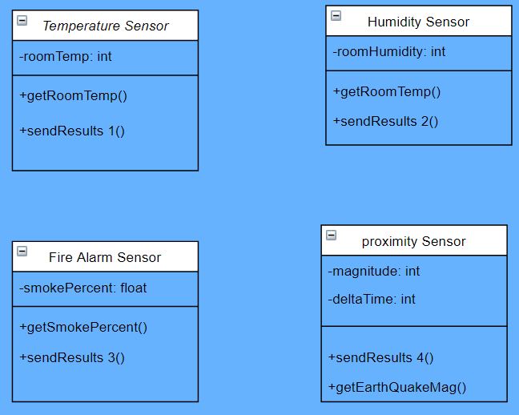

**-------------------------------------------------------------XXX--------------------------------------------------------**

**Assignment No 4: Refine the class diagram to get the final complete class diagram. (2)**

**Sol –**

**Complete Class Diagram –**

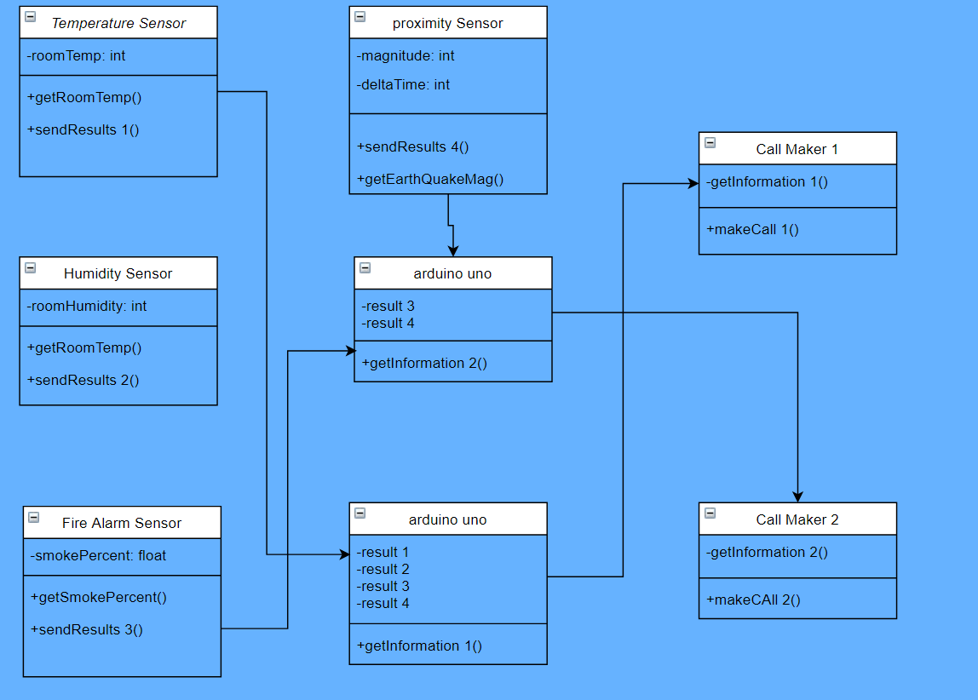

**-------------------------------------------------------------XXX--------------------------------------------------------**

**Assignment No 5: Using Use case diagram and class diagram construct the interaction diagrams like sequence, collaboration and state chart diagram. (4)**

**Sol:**

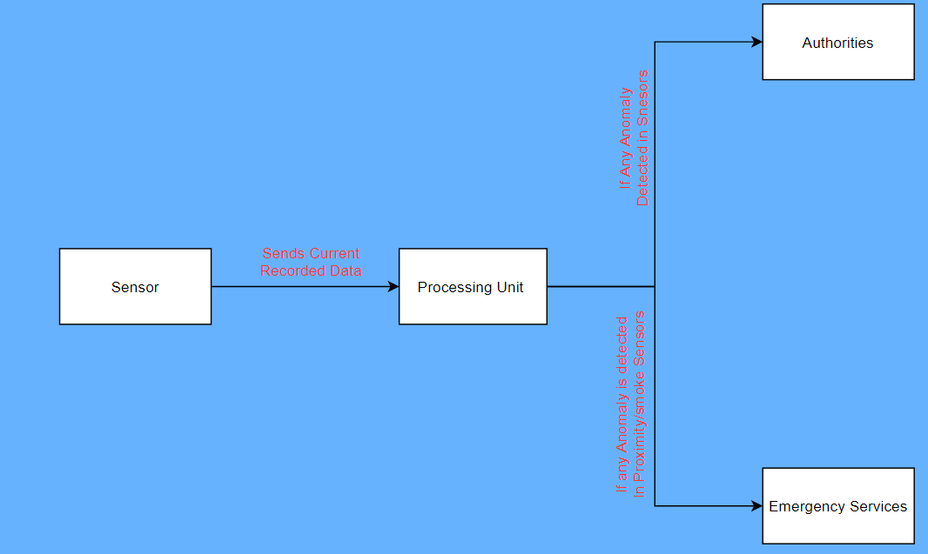

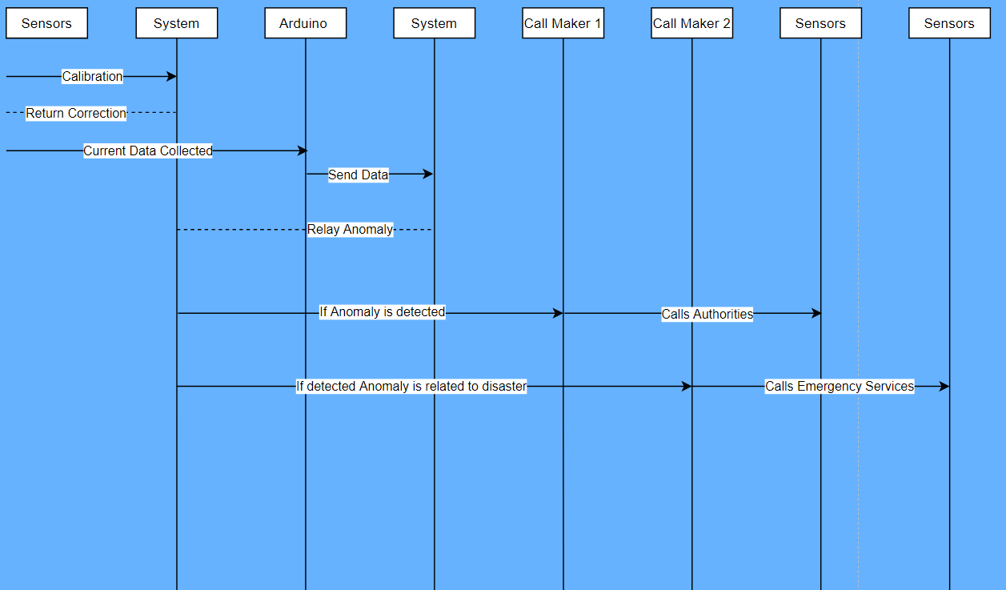

**-------------------------------------------------------------XXX--------------------------------------------------------**

**Assignment No 6: Draw an Activity diagram to capture the various activities involved while capturing the behavioral aspect of the system. (2)**

**Sol –**

**Activity Diagram –**

**User Activity Diagram**



**-------------------------------------------------------------XXX--------------------------------------------------------**

**Assignment No 7: Draw the component and deployment diagram to analyze the environmental and deployment view of the system.(2+2)**

**Sol –**

**Component Diagram –**

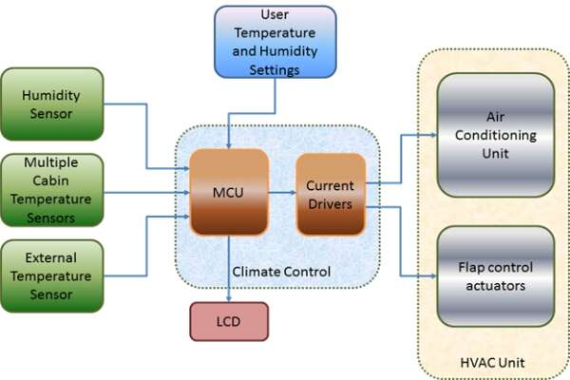

**Deployment Diagram –**

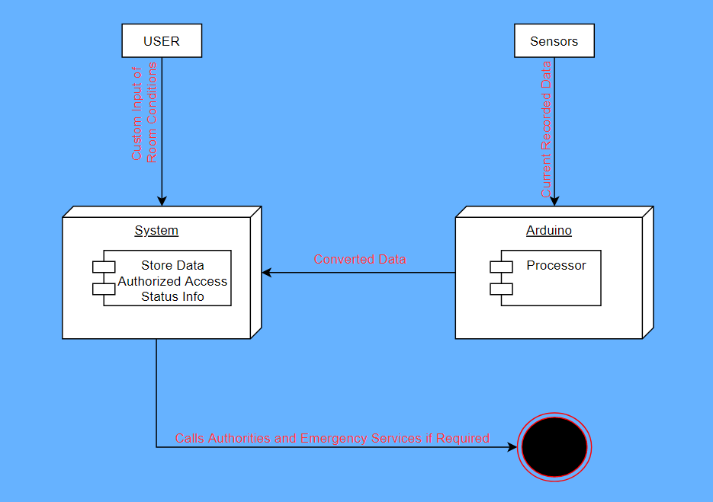

**-------------------------------------------------------------XXX--------------------------------------------------------**

**Assignment No 9)Prototype development(20)**

**Sol –**

**-------------------------------------------------------------XXX--------------------------------------------------------**